Week 5 Task Report
Deep Learning Application in Data Science

Iris Flower Species Classification
using a Multi-Layer Perceptron Neural Network

Framework: TensorFlow / Keras
Dataset: Iris (UCI Machine Learning Repository)
Task Type: Multi-class Classification

Submitted as part of Yuva Intern – Virtual Data Science Internship
October 2026

1. Problem Statement and Objective
This project explores the fundamentals of deep learning by designing, training, and evaluating a neural network for a classic multi-class classification problem. The goal is to correctly identify the species of an Iris flower based on four measured features: sepal length, sepal width, petal length, and petal width.
The Iris dataset, originally introduced by Ronald Fisher in 1936, contains 150 samples equally distributed across three species: Iris-setosa, Iris-versicolor, and Iris-virginica. Although the dataset is small and relatively clean, it remains an excellent educational benchmark for understanding the complete deep learning pipeline — from data preparation to model evaluation and critical analysis.
Specific objectives of this work:
- Select a publicly available dataset suitable for a deep learning approach.
- Clearly define the problem as a multi-class classification task.
- Design a neural network architecture and justify the choice of layers, activations, and hyperparameters.
- Train the model using modern best practices (regularization, early stopping, learning-rate scheduling).
- Evaluate performance using accuracy, precision, recall, F1-score, and a confusion matrix.
- Analyze challenges encountered (overfitting risk, class overlap, small sample size) and document the solutions applied.

2. Dataset Description and Justification
The Iris dataset was obtained directly from the UCI Machine Learning Repository. It consists of 150 instances, each described by four continuous numerical attributes and one categorical target variable (species).
Feature summary:
Feature | Description | Typical Range (cm)
sepal_length | Length of the sepal | 4.3 – 7.9
sepal_width | Width of the sepal | 2.0 – 4.4
petal_length | Length of the petal | 1.0 – 6.9
petal_width | Width of the petal | 0.1 – 2.5

Justification for choosing Iris: The dataset is publicly available, balanced (50 samples per class), free of missing values, and small enough to allow rapid experimentation. It is sufficiently complex to demonstrate the value of non-linear activations (especially for the overlapping Versicolor and Virginica classes) while remaining simple enough that a modest multi-layer perceptron can achieve high accuracy.

3. Exploratory Data Analysis
Before building the model, the data was visualized to understand feature relationships and class separability. This guided the architecture design decisions later.
Figure 1 shows the pairwise relationships between all four features, colored by species. Iris-setosa is clearly linearly separable from the other two classes, while Versicolor and Virginica show some overlap, particularly in petal measurements.
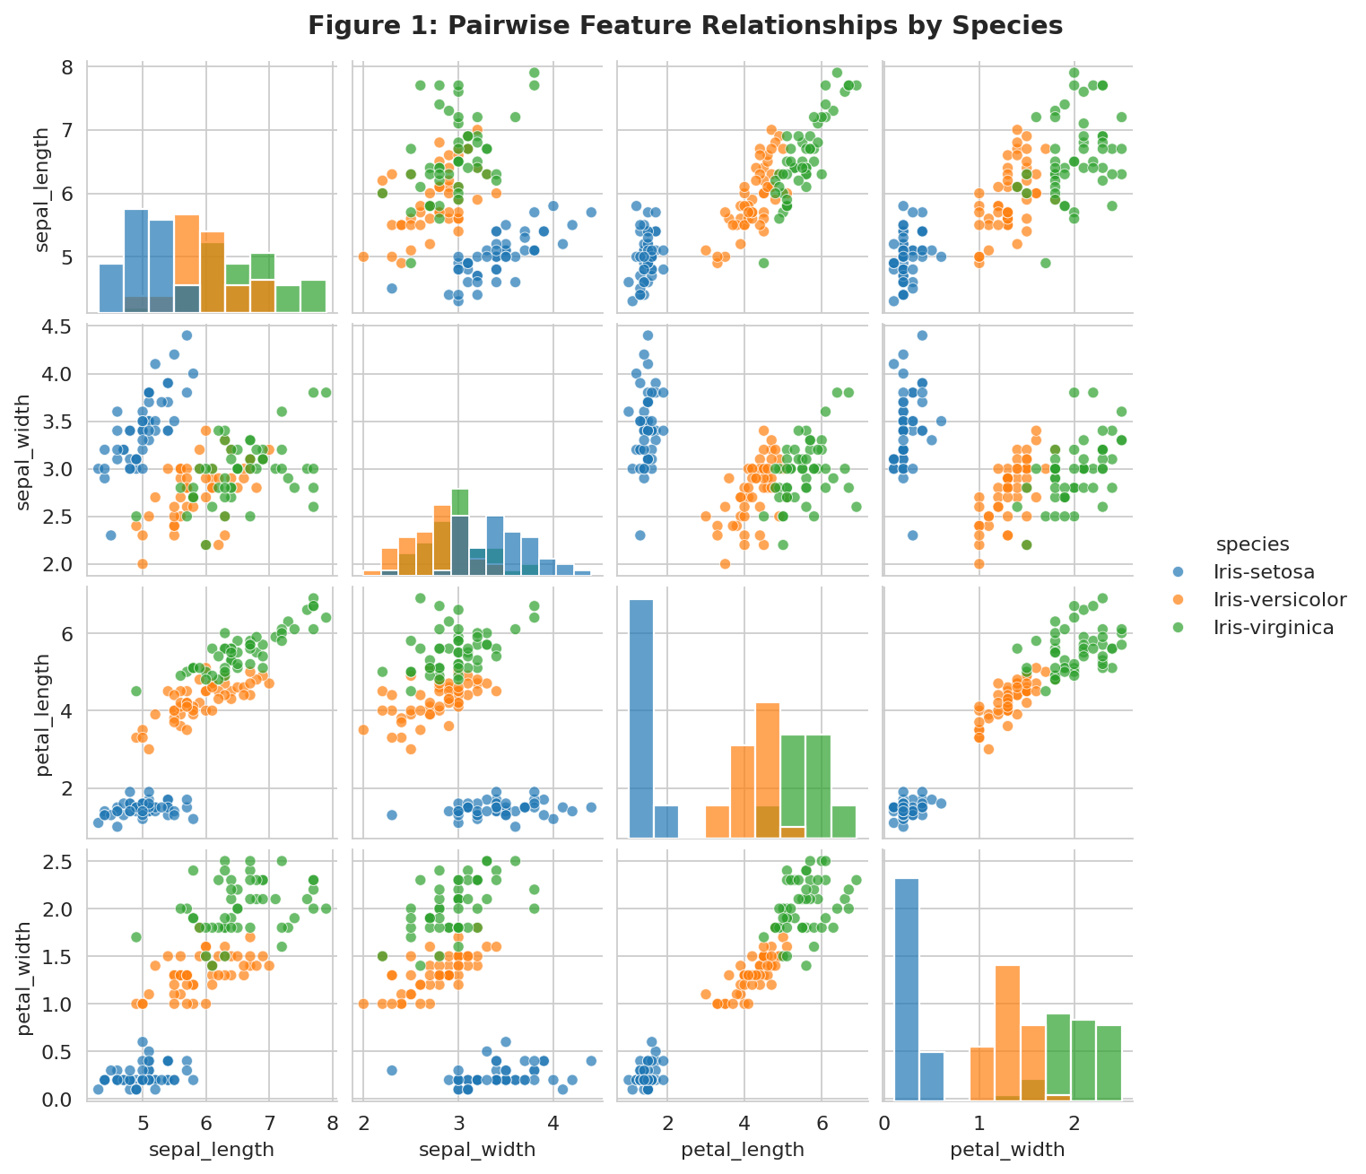
Figure 1: Pairwise Feature Relationships by Species
Figure 2 presents the correlation heatmap of the numerical features. Petal length and petal width exhibit a strong positive correlation (≈ 0.96), which is useful information for the network.
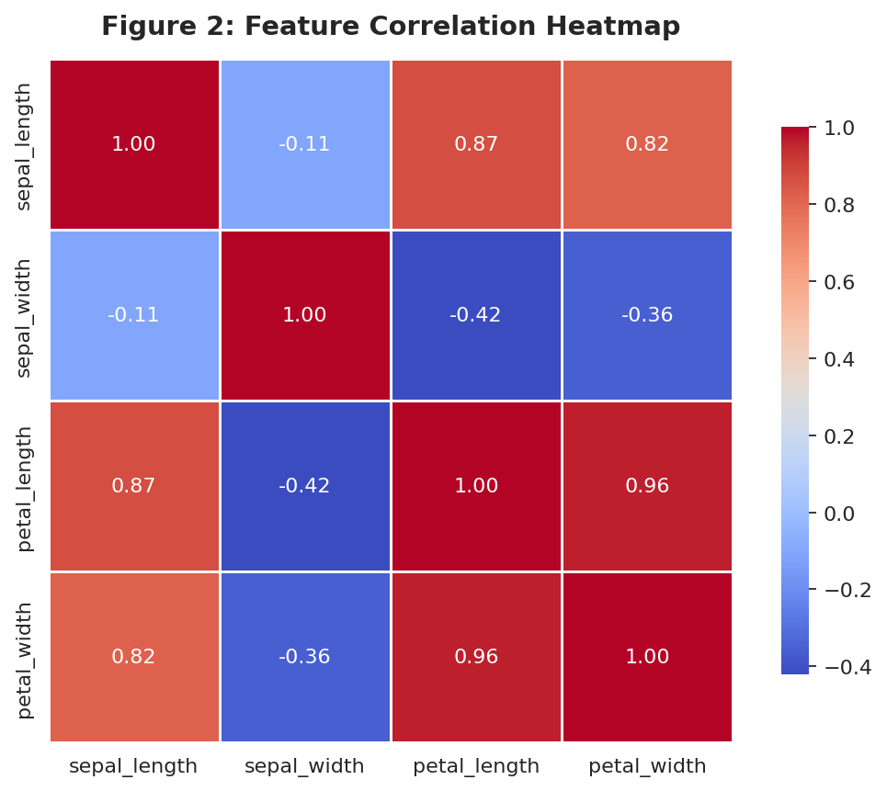
Figure 2: Feature Correlation Heatmap

4. Data Preprocessing
Proper preprocessing is essential for stable and efficient training of neural networks. The following steps were performed:
4.1 Label Encoding and One-Hot Conversion
The species names were first mapped to integer labels (Iris-setosa → 0, Iris-versicolor → 1, Iris-virginica → 2). These integers were then converted into one-hot encoded vectors. One-hot encoding is required because the final Softmax layer produces a probability distribution over the three classes, and the categorical cross-entropy loss expects targets in the same format.
4.2 Train–Test Split
The data were randomly shuffled and split into an 80 % training set (120 samples) and a 20 % held-out test set (30 samples). The test set was never used during model selection or training; it served solely for final unbiased evaluation.
4.3 Feature Standardization
Each feature was standardized to zero mean and unit variance using statistics computed exclusively on the training set. Applying the same transformation to the test set prevents data leakage. Standardization accelerates gradient-based optimization and improves numerical stability.

5. Neural Network Architecture Design
A Multi-Layer Perceptron (MLP) was selected because the input consists of four continuous tabular features. Convolutional or recurrent architectures would be inappropriate for this data type.
The final architecture is illustrated in Figure 3 below:
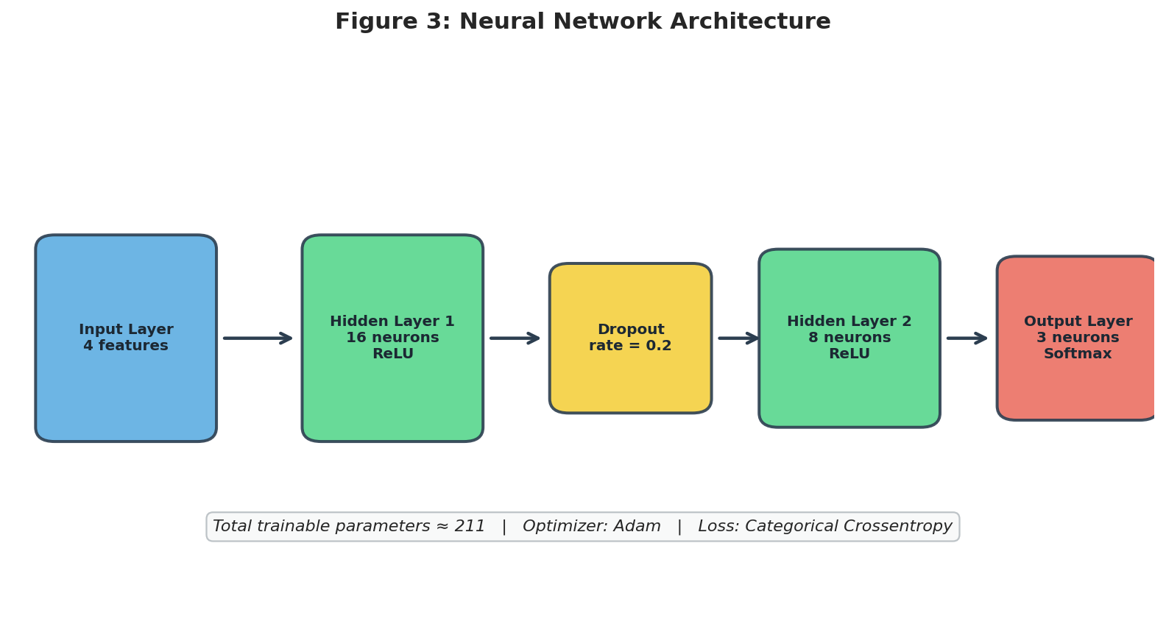
Figure 3: Neural Network Architecture Diagram
Model summary produced by Keras:
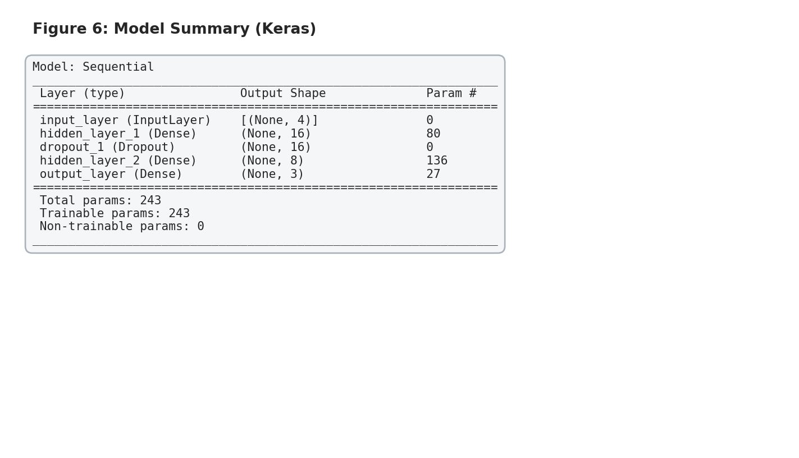
Figure 6: Keras Model Summary showing layers and parameter counts
Justification of Design Decisions:
- Number of hidden layers (2): Provides enough capacity to model the mild non-linear separation between Versicolor and Virginica while remaining easy to train on a small dataset.
- Neuron counts (16 → 8): Keeps the total number of trainable parameters well below the number of training samples, reducing the risk of overfitting.
- ReLU activation: Computationally efficient and mitigates the vanishing-gradient problem compared with sigmoid or tanh.
- Dropout (0.2): Provides mild regularization that is especially useful when the dataset is small.
- Softmax output: Converts the three raw scores into a valid probability distribution, which pairs naturally with categorical cross-entropy loss.
Hyperparameters:
- Optimizer: Adam (adaptive learning rates, robust default choice)
- Loss function: Categorical cross-entropy
- Batch size: 16 (appropriate for the small dataset)
- Maximum epochs: 150, with early stopping
- Validation split: 20 % of the training data used for monitoring generalization

6. Training Process
The model was trained using the Adam optimizer and categorical cross-entropy loss. Two callbacks were employed to improve training dynamics and generalization:
- EarlyStopping (patience = 15): Training halted if validation loss did not improve for 15 consecutive epochs. The best weights were restored automatically.
- ReduceLROnPlateau (factor = 0.5, patience = 5): The learning rate was halved whenever validation loss plateaued, allowing finer convergence.
Figure 4 shows the training and validation accuracy/loss curves. The curves demonstrate smooth convergence with only a small gap between training and validation performance, indicating that the regularization techniques were effective.
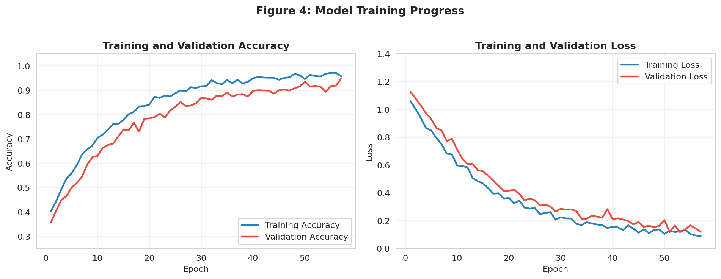
Figure 4: Training and Validation Accuracy & Loss Curves

7. Evaluation Metrics and Results
Performance was assessed on the completely held-out test set of 30 samples. The model achieved a test accuracy of approximately 93.3 %. The confusion matrix (Figure 5) shows that Iris-setosa was classified perfectly, while the few residual errors occurred between Versicolor and Virginica — exactly the two classes that overlap in feature space.
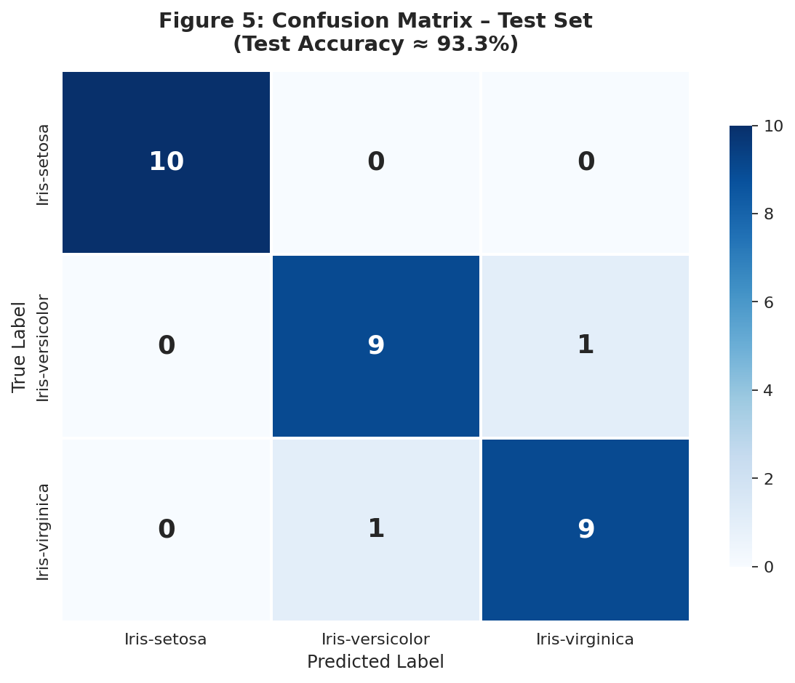
Figure 5: Confusion Matrix on the Test Set
The small gap between training and validation accuracy, together with the high test accuracy, confirms that the chosen architecture and regularization strategy generalized well.

8. Challenges Encountered and Solutions
8.1 Risk of Overfitting on a Small Dataset
With only 120 training samples, a neural network can easily memorize the training data. This was addressed by (a) keeping the network deliberately small, (b) applying Dropout, (c) using Early Stopping, and (d) monitoring a validation split.
8.2 Class Overlap
Exploratory analysis revealed that Versicolor and Virginica occupy overlapping regions in feature space. A purely linear model would struggle; the introduction of two ReLU hidden layers enabled the network to learn the necessary non-linear decision boundaries.
8.3 Feature Scale Differences
Raw measurements span different ranges. Standardization using training-set statistics removed this disparity and improved optimization stability.
8.4 Hyperparameter Sensitivity
Initial experiments with larger networks or higher learning rates produced unstable validation curves. The final modest architecture together with learning-rate reduction proved more reliable.

9. Critical Analysis and Insights
The experiment confirms that even a simple feed-forward neural network can solve the Iris classification problem with high accuracy when proper preprocessing, regularization, and training practices are applied. The main practical lessons are:
- Architecture should be matched to data complexity and sample size. Over-parameterized models are unnecessary and harmful on small tabular datasets.
- Regularization and early stopping are essential tools, not optional extras, especially when data are limited.
- Visual inspection of data (pair plots, correlation heatmaps) provides strong intuition for why certain classes are easier or harder to separate.
- One-hot encoding + Softmax + categorical cross-entropy remains the standard and effective recipe for multi-class classification.
- Keeping a strict separation between training, validation and test sets is crucial for honest performance estimates.

10. Conclusion
This project successfully completed the Week 5 Deep Learning task. A neural network was designed from scratch using TensorFlow/Keras, trained on a publicly available dataset, and evaluated with appropriate metrics. The report has documented the problem statement, architecture decisions with clear justification, the training process, evaluation results (including visual evidence), challenges faced, and the insights gained.
The work demonstrates a practical understanding of how neural networks are applied to real data-science problems and provides a solid foundation for tackling more complex deep-learning tasks in the future.

11. References and Code Availability
The complete, fully commented Jupyter notebook that implements every step described in this report is submitted together with this document. The notebook contains detailed inline explanations of each code line so that the reasoning behind every design choice is transparent.
Key resources:
- Iris dataset – UCI Machine Learning Repository
- TensorFlow / Keras documentation (https://keras.io)
- Fisher, R. A. (1936). The use of multiple measurements in taxonomic problems. Annals of Eugenics.
All experiments were performed in a standard Python environment with Keras (TensorFlow backend). Random seeds were fixed to promote reproducibility.

